### 

### Semester Two Examination, 2020

### Question/Answer booklet

# MATHEMATICS METHODS

**UNIT 3 & 4**

## Section One:

## Calculator-free

|  |  |
| --- | --- |
| **Your Name:** |  |
| **Your Teacher’s Name:** |  |

## Time allowed for this section

Reading time before commencing work: five minutes

Working time: fifty minutes

## Materials required/recommended for this section

***To be provided by the supervisor***

This Question/Answer booklet

Formula sheet

***To be provided by the candidate***

Standard items: pens (blue/black preferred), pencils (including coloured), sharpener, correction fluid/tape, eraser, ruler, highlighters

Special items: nil

## Important note to candidates

No other items may be taken into the examination room. It is **your** responsibility to ensure that you do not have any unauthorised material. If you have any unauthorised material with you, hand it to the supervisor **before** reading any further.

|  |  |  |  |  |  |
| --- | --- | --- | --- | --- | --- |
| Question | Marks | Max | Question | Mark | Max |
| 1 |  | 4 | 5 |  | 8 |
| 2 |  | 7 | 6 |  | 12 |
| 3 |  | 7 | 7 |  | 7 |
| 4 |  | 5 |  |  |  |

**Structure of this paper**

|  |  |  |  |  |  |
| --- | --- | --- | --- | --- | --- |
| Section | Number of questions available | Number of questions to be answered | Working time (minutes) | Marks available | Percentage of examination |
| Section One:  Calculator-free | 7 | 7 | 50 | 50 | 35 |
| Section Two:  Calculator-assumed | 10 | 10 | 100 | 94 | 65 |
|  |  |  |  | **Total** | 100 |

**Instructions to candidates**

1. The rules for the conduct of the Western Australian Certificate of Education ATAR course examinations are detailed in the *Year 12 Information Handbook 2019*. Sitting this examination implies that you agree to abide by these rules.
2. Write your answers in this Question/Answer booklet.
3. You must be careful to confine your answers to the specific questions asked and to follow any instructions that are specific to a particular question.
4. Additional pages for the use of planning your answer to a question or continuing your answer to a question have been provided at the end of this Question/Answer booklet. If you use the space to continue an answer, indicate in the original answer space where the answer is continued, i.e. give the page number.
5. **Show all your working clearly.**Your working should be in sufficient detail to allow your answers to be checked readily and for marks to be awarded for reasoning. Incorrect answers given without supporting reasoning cannot be allocated any marks. For any question or part question worth more than two marks, valid working or justification is required to receive full marks. If you repeat any question, ensure that you cancel the answer you do not wish to have marked.
6. It is recommended that you **do not use pencil**, except in diagrams.
7. The Formula sheet is **not** to be handed in with your Question/Answer booklet.

**Section One: Calculator-free (50 Marks)**

This section has **seven** questions. Answer **all** questions. Write your answers in the spaces provided.

Spare pages are included at the end of this booklet. They can be used for planning your responses and/or as additional space if required to continue an answer.

● Planning: If you use the spare pages for planning, indicate this clearly at the top of the page.

● Continuing an answer: If you need to use the space to continue an answer, indicate in the original answer space where the answer is continued, i.e. give the page number. Fill in the number of the question that you are continuing to answer at the top of the page.

Working time: 50 minutes.

**Question 1 (4 marks)**

#### Find the area bounded by the curve , the Latex formula-axis and the lines $x=1$ and $x=5.$ Leave your answer in the exact simplified form.

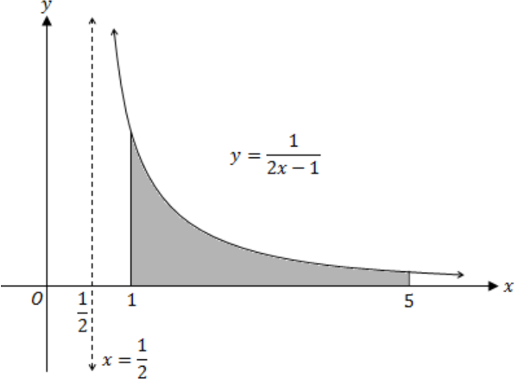

$${\int_{1}^{5}{\frac{1}{2x-1} dx=[\frac{1}{2}ln\left(2x-1\right)]}}_{1}^{5}=\frac{1}{2}ln9-\frac{1}{2}ln1=\frac{1}{2}ln9$$

* Use integral for area under the curve
* Use the correct boundary points
* Determine the correct antiderivative
* Determine the correct simplified answer as one term.

**Question 2 (7 marks)**

Suppose that $f\left(x\right)$ and $g\left(x\right)$ are diﬀerentiable functions that satisfy the following properties.

|  |  |
| --- | --- |
| $$f(3)$$ | $$-2$$ |
| $$g(3)$$ | $$3$$ |
| $$f' (3)$$ | $$-1$$ |
| $$g' (3)$$ | $$0$$ |

1. Given $h\left(x\right)=\frac{f\left(x\right)}{g\left(x\right)},$ determine the value for $h^{'}\left(3\right).$ (2 marks)

$$h^{'}\left(3\right)=\frac{f^{'}\left(3\right)g\left(3\right)-f\left(3\right)g^{'}\left(3\right)}{{\left[g\left(3\right)\right]}^{2}}=\frac{\left(-1\right)\left(3\right)-\left(-2\right)\left(0\right)}{3^{2}}=-\frac{1}{3}$$

* Demonstrate the use of quotient rule correctly
* Calculate the correct answer

1. Given $T\left(x\right)=f\left(g\left(x\right)\right),$ determine the value for $T’(3)$. (2 marks)

$$T^{'}\left(3\right)=f^{'}\left(g\left(3\right)\right)×g^{'}\left(3\right)=f^{'}\left(3\right)×g^{'}\left(3\right)=\left(-1\right)\left(0\right)=0$$

* Demonstrate the use of chain rule correctly
* Calculate the correct answer

1. Given $S\left(x\right)=ln⁡(-f\left(x\right))$, determine the value for $S^{'}\left(3\right).$ (3 marks)

$$S^{'}\left(3\right)=\frac{1}{-f\left(3\right)}×{(-f}^{'}\left(3\right))=\frac{1}{2}$$

* Demonstrate the differentiation of natural log correctly
* Demonstrate the differentiation of natural log correctly with the use of chain rule
* Calculate the correct answer

**Question 3 (7 marks)**

(a) Determine $\frac{d}{dx} x\ln\left(x\right)$ and simplify your answer (3 marks)

$$\frac{d}{dx}=\ln\left(x\right)+\frac{x}{x}=\ln\left(x\right)+1$$

* Use product rule correctly
* Differentiate $\ln\left(x\right)$ correctly
* Obtain the simplified expression

(b) Hence determine $\int_{e}^{e^{2}}{ln⁡(x)} dx$ (4 marks)

$$\int{ln⁡(x)}+1dx=\int{\frac{d}{dx} x\ln\left(x\right)}dx=\int{ln⁡(x)} dx+\int{1} dx$$

$$\int{ln⁡(x)} dx=\int{\frac{d}{dx} x\ln\left(x\right)}dx-\int{1} dx=xln\left(x\right)-x+c$$

$$\int_{e}^{e^{2}}{\ln\left(x\right)}dx={\left[xln\left(x\right)-x\right]}_{e}^{e^{2}}={(2e}^{2}-e^{2})-(e-e)=e^{2}$$

* Use linearity principle (first line)
* Use the Fundamental Theorem of Calculus
* Obtain antiderivative and subs correct limits
* Give simplified answer

**Question 4 (5 marks)**

A rectangle is inscribed with its base on the $x$-axis and its upper corners on the parabola

$y=1-x^{2}$. Determine the dimensions of such a rectangle with the greatest possible area.

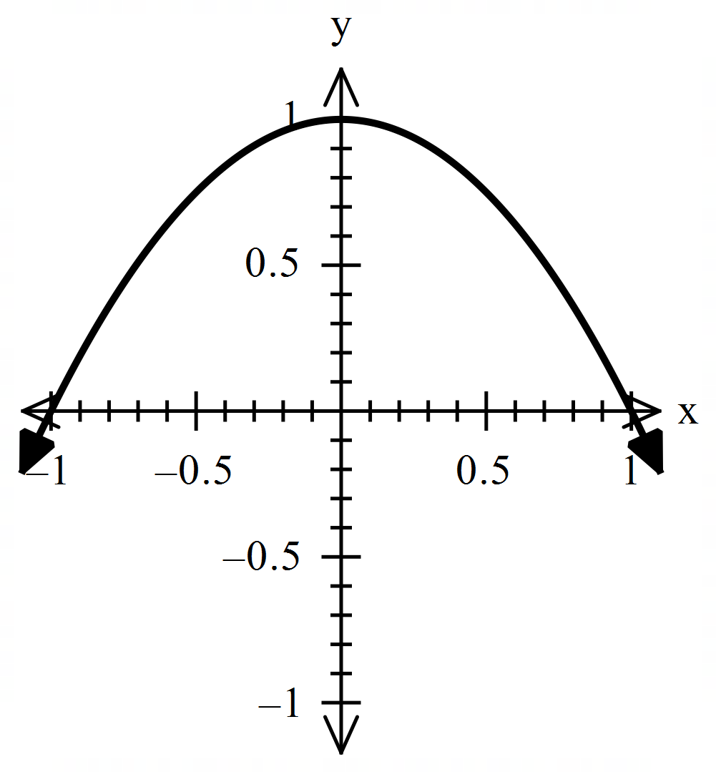

$$A=2x\left(1-x^{2}\right)=-2x^{3}+2x$$

$$\frac{dA}{dx}=-6x^{2}+2=0, x^{2}=\frac{1}{3}, x=-\frac{1}{\sqrt{3}}\left(reject\right) or\frac{1}{\sqrt{3}}$$

$$\frac{d^{2}A}{dx^{2}}=-12x=-\frac{12}{\sqrt{3}}<0, hence local maximum at x=\frac{1}{\sqrt{3}} units$$

$$y=1-\frac{1}{3}=\frac{2}{3} units$$

$$Dimensions are width=\frac{2}{√3} units and height=\frac{2}{3}units$$

* Write an equation for area in terms of $x$
* Determine first derivative
* Equate first derivative to 0 and solve for $x$
* Use second derivative or otherwise to justify.
* State dimensions for both $x$ and $y.$

**Question 5 (8 marks)**

(a) Find an equation of the line perpendicular to the graph of $y=\ln\left(x-1\right)$ at $x=2.$ (4 marks)

$$\frac{dy}{dx}=\frac{1}{x-1},$$

$$x=2, \frac{dy}{dx}=1,$$

$$Hence, the gradient of line is -1.$$

$At x=2, y=0$, $substituting \left(2, 0\right), - \left(2\right)+c=0, c=2$

$$Therefore, y=-x+2$$

* Differentiate y correctly
* Calculate $\frac{dy}{dx}$ at $x=2$
* Calculate constant $c$ correctly
* Write the correct equation of the line

(b) Find an equation of the line tangent to the graph of $y=x^{2}+sin⁡(\frac{π}{2}x)$ at $x=-1$.

(4 marks)

$$\frac{dy}{dx}=2x+\frac{π}{2}cos⁡(\frac{π}{2}x)$$

$At x=-1, \frac{dy}{dx}=-2+0=-2$,

$$y=1-1=0$$

$$Substituting (-1, 0), 0=-2(-1)+c, c=-2$$

$$Hence, y=-2x-2$$

* Differentiate y correctly
* Calculate $\frac{dy}{dx}$ at $x=-1$
* Calculate constant c correctly
* Write the correct equation of the line

**Question 6 (12 marks)**

The discrete random variable $X$ has probability distribution given by

|  |  |  |  |  |  |
| --- | --- | --- | --- | --- | --- |
| $$x$$ | $$-1$$ | $$0$$ | $$1$$ | $$2$$ | $$3$$ |
| $$P(X=x)$$ | $$\frac{1}{5}$$ | $$a$$ | $$\frac{1}{10}$$ | $$a$$ | $$\frac{1}{5}$$ |

where $a$ is a constant.

(a) Determine the value of $a.$ (2 marks)

$$2a+\frac{1}{5}+\frac{1}{10}+\frac{1}{5}=1, a=\frac{1}{4}$$

* Use the sum of probability equals 1
* Calculate the correct value for $a.$

(b) Determine $E\left(X\right).$ (2 marks)

$$E\left(X\right)=\left(-1\right)\left(\frac{1}{5}\right)+1\left(\frac{1}{10}\right)+2\left(\frac{1}{4}\right)+3\left(\frac{1}{5}\right)=1$$

* Set up a correct equation for mean
* Calculate the correct answer

(c) Determine $Var\left(X\right).$ (3 marks)

$Var\left(X\right)={\left(-1-1\right)}^{2}\left(\frac{1}{5}\right)+{\left(0-1\right)}^{2}\left(\frac{1}{4}\right)+{\left(1-1\right)}^{2}\left(\frac{1}{10}\right)+{\left(2-1\right)}^{2}\left(\frac{1}{4}\right)+{\left(3-1\right)}^{2}\left(\frac{1}{5}\right)$

$$=\frac{4}{5}+\frac{1}{4}+\frac{1}{4}+\frac{4}{5}$$

$$=\frac{21}{10} or 2.1$$

* Set up an equation for variance
* Calculate the correct answer

The random variable $Y=6-2X$

(d) Determine $Var\left(Y\right).$ (2 marks)

$$Var\left(Y\right)={\left(-2\right)}^{2}\left(2.1\right)=8.4$$

* Use ${\left(-2\right)}^{2} or 4$
* Calculate the correct answer

(e) Calculate $P(X≥Y)$. (3 marks)

$$X≥6-2X, X≥2$$

$$P\left(X≥2\right)=P\left(X=2\right)+P\left(X=3\right)=\frac{1}{4}+\frac{1}{5}=\frac{9}{20}$$

* Recognise $P\left(X≥Y\right)=P(X≥2)$
* Use cumulative probability correctly
* Calculate the correct answer

**Question 7 (7 marks)**

The following diagram shows the instantaneous velocity $v\left(t\right) m/min$ of a moving object during the first 5 minutes, where $t$ is in minutes.

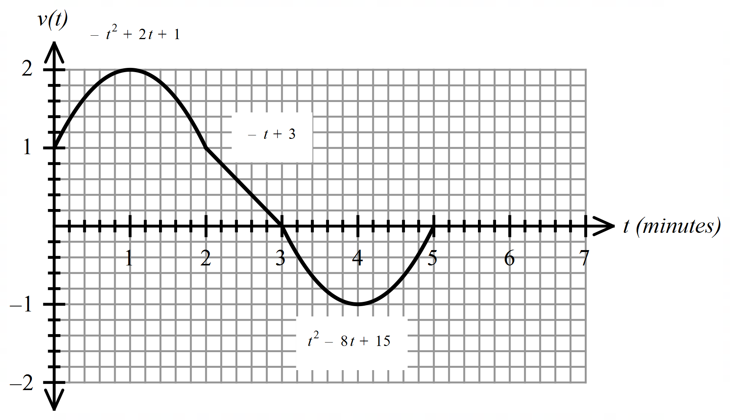

$$v\left(t\right)=\left\{\begin{aligned}-t^{2}+2t+1, 0≤t<2 \\ -t+3, 2≤t<3 \\ t^{2}-8t+15, 3≤t<5 \\ g(t), 5≤t≤7\end{aligned}\right.$$

(a) Determine $\int_{0}^{5}{v\left(t\right) dt}$. (3 marks)

$$\int_{0}^{5}{v\left(t\right) dt}=2+\frac{1}{2}=\frac{5}{2}$$

√ recognizes that two parabolas are congruent and negate each other

√ determines area of rectangle and triangle

√determines net area

OR

√writes definite integral sum

√anti-diffs and subs correct limits

√determines sum

(b) Determine a formula for a linear function $g\left(t\right)=at+b, 5≤t≤7$, given that the object returns to the origin at the end of 7 minutes, that is , $\int_{0}^{7}{v\left(t\right) dt}=0.$ (4 marks)

$$t=5, v\left(t\right)={\left(5\right)}^{2}-\left(8\right)\left(5\right)+15=0$$

$$5a+b=0, b=-5a$$

$$\int_{5}^{7}{at+b dt=-\frac{5}{2}}$$

$$\int_{5}^{7}{at-5a dt={\left[\frac{at^{2}}{2}-5at\right]}_{5}^{7}=\left[\frac{49a}{2}-35a\right]-\left[\frac{25a}{2}-25a\right]=}2a=-\frac{5}{2}$$

$$a=-\frac{5}{4}$$

$$b=\frac{25}{4}$$

$$g\left(t\right)=-\frac{5}{4}t+\frac{25}{4}$$

√ uses the negative result of part a as area from 5 to 7

√integrates linear rule

√ obtains b in terms of a (follow through only for b=-5a)

√solves for a and b

OR

√determines height of triangle

√ determines gradient

√ subs grad into y=mx+c

√ solves for c (follow through only for(5,0) used)

Additional working space

Question number: ________

Additional working space

Question number: ________

Additional working space

Question number: ________